

Computer organization and assembly language
Project Report
Submitted To:
Sir Khalid Baloch
Registration No:
24-cs-013
Submitted By:
Jawad Ahmed
Section
C
DEPARTMENT OF Computer Science UNIVERSITY, Taxila
2024-2028

Project Report Based On Remote Area Resource Management System
Introduction:
Remote areas often face severe challenges in managing essential resources such as food, water, and daily supplies due to limited infrastructure and almost no internet connectivity. Conventional database management systems require high memory, storage, and continuous network access, which makes them unsuitable for such environments.
To overcome these limitations, this project presents a low-level computing solution using Assembly Language on an edge device such as Raspberry Pi. The system efficiently manages population and resource consumption data using minimal memory and storage
Problem Statement:
The government plans to initiate a welfare program for people living in remote areas. The program requires maintaining accurate data related to:
- Population (family members)
- Water consumption
- Flour consumption
- Pulses consumption
Due to limited internet availability, low storage, and restricted memory on edge devices, a lightweight and offline database solution is required. Engineers have advised the use of Assembly Language to design a file-based database system that can operate efficiently under these constraints.
Objectives of the System:
The main objective of this project is to design a lightweight database system using assembly language. The system allows users to add, update, delete, display, and sort records while preventing duplicate entries. It also calculates total resource consumption for effective planning.
Scope of the Project:
This project focuses on small-scale data management suitable for embedded systems. It is limited to text-based files such as CSV or TXT and does not rely on graphical interfaces or internet connectivity.
System Requirements:
The system requires a Raspberry Pi or similar edge device, minimal storage space, and an assembler environment. Basic input/output hardware such as a keyboard and display is also required for interaction.
Hardware Requirements:
- Raspberry Pi or similar edge device
- Keyboard and display
- Minimal storage space
Software Requirements:
- EMU8086 or similar assembler
- DOS-based file handling support
- Assembly Language environment
Database Design:
- The database is implemented using arrays in assembly language.
- Each record represents one family and is stored in a row format.
- Columns store serial number, name, family members, and water, flour, and pulses data.
- Fixed memory allocation is used to ensure efficient memory management.
- The design is optimized for low-resource embedded systems.
- Data is stored locally without requiring internet connectivity.
Functional Features:
The system provides the following functionalities:
- Add Record
- Adds a new record to memory and file
- Prevents duplicate serial numbers
- Stores name and resource values
- Update Record
- Searches record using Sr#
- Allows modification of all fields
- Updates file after changes
- Delete Record
- Removes a record logically
- Clears serial number entry
- Updates database file
- Display Records
- Displays all valid records in tabular form
- Shows individual resource consumption
- Calculates totals automatically
- Total Calculations
- Total family members
- Total water consumption
- Total flour consumption
- Total pulses consumption
File Handling Mechanism:
The system uses DOS interrupt 21h for file operations:
- File creation (3Ch)
- File writing (40h)
- File reading (3Fh)
- File closing (3Eh)
All records are saved in ASCII format for easy readability and persistence.
Sorting and Validation:
Sorting functionality allows data arrangement based on family size or resource usage. Validation ensures that no duplicate serial numbers are entered, maintaining data integrity.
Output:

We add our first record
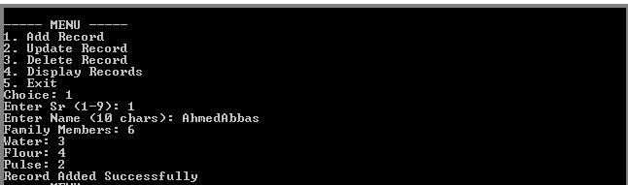
We add our second record
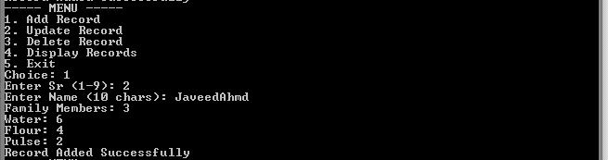
And we add our third record
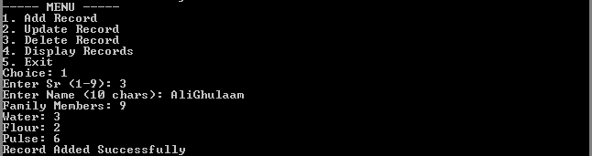
Displayed all records
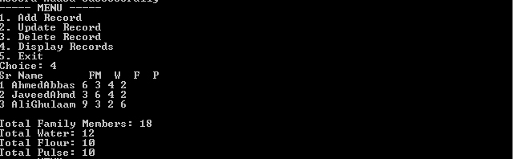

Delete our third record
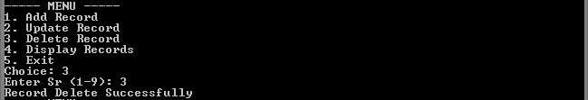
After deleting the third record
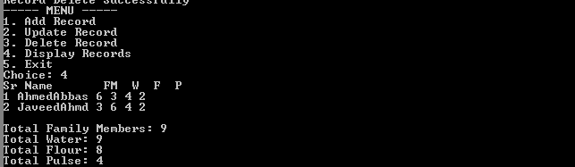
Update the record through serial no
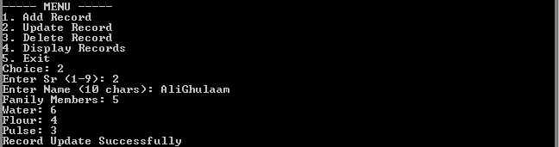
Records were displayed after updating the record
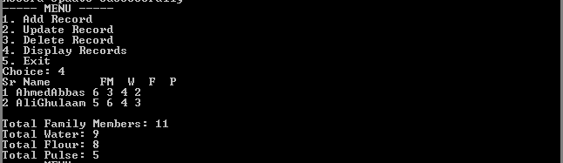
An invalid choice was entered
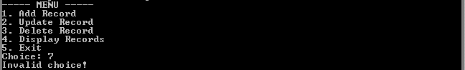
This message was displayed due to duplicate of serial no
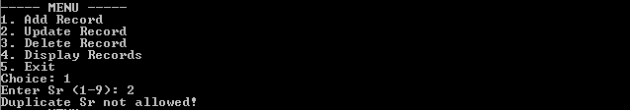
Advantages of Using Assembly Language:
- Requires very low memory and storage space.
- Executes faster due to low-level assembly language implementation.
- Works efficiently on embedded and edge devices.
- Does not depend on internet access, making it suitable for remote areas.
- Provides direct control over hardware resources.
Limitations:
- Supports only a limited number of records.
- User interface is text-based and not graphical.
- Requires basic understanding of assembly language to modify.
- Not suitable for large-scale databases.
- Lacks advanced security features such as encryption.
Future Enhancements:
Future improvements may include encryption, sensor integration, automated data collection, and migration to more advanced embedded platforms.
Conclusion:
This project successfully demonstrates that Assembly Language can be effectively used to design a database system for remote and resource-constrained environments. The system fulfills all requirements of the Complex Computing Problem by providing a reliable, offline, and efficient solution. It is highly suitable for government welfare programs in remote areas where modern database systems are impractical.

